**Project Initialization and Planning Phase**

| Date | 15 March 2024 |
| --- | --- |
| Team ID | xxxxxx |
| Project Name | Forecasting Economic Prosperity: Leveraging Machine Learning for GDP per Capita Prediction |
| Maximum Marks | 3 Marks |

**Define Problem Statements (Customer Problem Statement Template):**

The project aims to utilize machine learning techniques for forecasting GDP per capita, a crucial indicator of economic prosperity. GDP per capita reflects the average income earned per person in a country and serves as a key measure of living standards and economic development. By leveraging historical GDP data along with a wide range of economic, social, and demographic factors, the machine learning model can generate forecasts that help policymakers, investors, and businesses understand and anticipate future economic trends.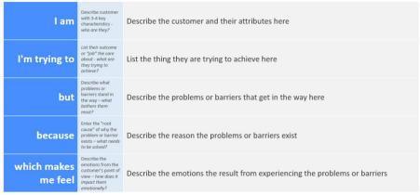

Reference: https://miro.com/templates/customer-problem-statement/

**Example:**



|  |  |  |  |  |  |
| --- | --- | --- | --- | --- | --- |
| **Problem**  **Statement (PS)** | **I am**  **(Customer)** | **I’m trying to** | **But** | **Because** | **Which makes me feel** |
| PS-1 | A policymaker, professional. | Forecast future GDP per capita accurately | Traditional methods are unreliable and don't consider all relevant factors. | I need precise insights for informed decision-making. | Frustrated with current methods and eager for a better solution. |
| PS-2 | A business leader. | Accurately predict GDP per capita. | Existing methods lack accuracy and comprehensive data. | I need reliable forecasts for strategic planning. | Unsatisfied with current tools and in need of a more effective solution. |